SeaLife DC800 Digital Camera (Item: SL180)
April 15, 2008

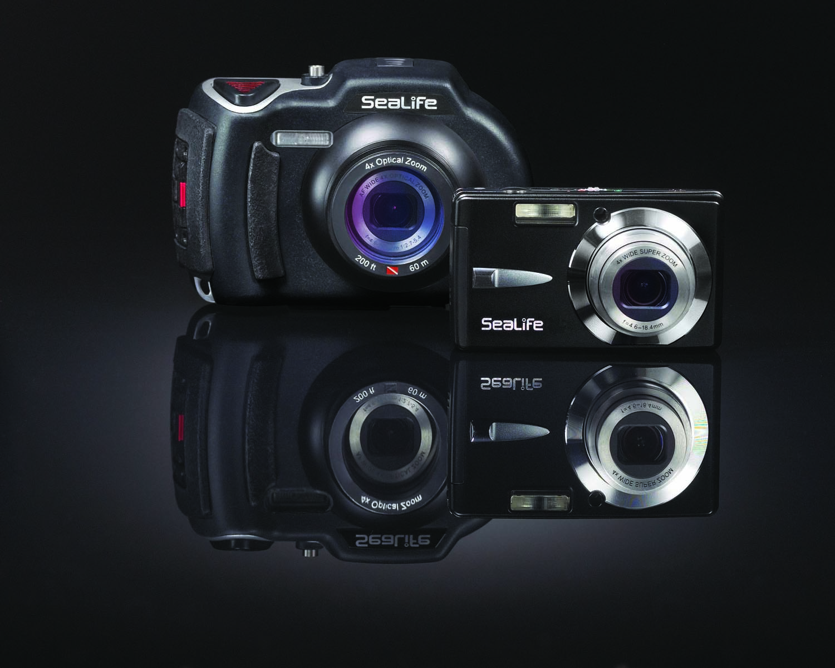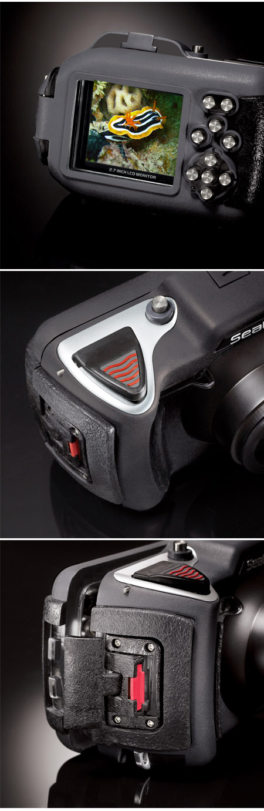

Technical Features

- 8 megapixel CCD for sharp, high-resolution pictures.
- Large 2.7” LCD for easy on-camera viewing
- 20X zoom - 4X optical zoom plus 5X digital.
- Auto focus to 2” (5cm)
- High capacity rechargeable lithium battery 1250mAh for 2 tank dive+ (2+ hours or 200+ pics)
- Fast shutter response time* and quick start-up for fast action photography. *( As fast as 0.1 sec in Ext Flash mode and landscape focus mode.)
- SD and SDHC card compatible up to 4GB.
- 22 Land modes – Automatically pre-sets the camera for the type of scene. Includes Face-detection, Anti-shake and aperture/shutter priority.
- 640x480 Video mode with Sound
- Wide angle optical lens 28mm to 112mm film equivalent.
- Removable inner camera for use on Land & Sea

Special SeaLife Features

- Depth tested to 200 ft (60m)
- Five Underwater Modes for sharp, colorful underwater pictures anywhere in the world:
  - Sea modes with 3 UW color correction settings (Oceans Blue, Oceans Green and Rivers/Lakes).
  - Ext Flash Auto mode for automatic exposure settings when using one or two external flash accessories. Ideal for beginner and intermediate UW photographers.
  - Ext Flash Manual mode for manual aperture and shutter speed exposure controls when using one or two external flash accessories. Ideal for advanced UW photographers.
- Spy Mode – The camera automatically shoots continuous pictures at set time intervals.
- Expandable with one or two SeaLife flashes.
- Pocket size removable inner camera.
- Rubber armored for durability and sure grip.
- Big shutter button and widespread controls for easy access, even with dive gloves on.

Detailed Specifications

Inner Camera:

Image Sensor: 8.0 mega pixel CCD
Color: 24-bit color (RGB)
Image Resolution: 3264x2448, 2816x2112, 2272x1704, 1600x1200, 640x480
File format: JPEG
Movie Resolution: 640x480 or 320x240 at 25 frames per second (FPS)
File format: AVI
Lens: 4X Optical Zoom
Aperture (f-stop): wide: F2.7 –Tele: F5.4
Focal Length: 4.6mm ~ 18.4mm (film equivalent = 28 ~ 112mm)
Focus type: Auto Focus
Focus modes: Auto, Macro, Landscape [Infinity], face detection.
Focusing ranges: Wide: 0.05m (2”) to infinity
Tele zoom: 0.35m (14”) to infinity
Shooting angle: Horizontal field of view / No zoom:
Land: 64.3° (wide)
Underwater: 43° (wide)
Zoom: 20X Total zoom
Optical: 4X
Digital: 5X
Playback: Up to 4X zoom
Shutter speed: Mechanical shutter
Land mode: 1/10 to 1/1500 second
Sea mode: 1/60 to 1/1500 second
External Flash mode: 1/80 to 1/500 second
Shutter Response: 0.3 seconds (Auto mode, flash off, landscape focus)
0.1 seconds (Auto mode, flash on, landscape focus)
Recycle time: About 3 seconds (depending on battery load and flash setting)
ISO: Auto, 64, 100, 200, 400, 800, 1600
Flash: Auto, Fill, Off, Red-Eye reduction,
Picture modes: Underwater modes, External Flash Auto, Ext Flash Manual and Sea mode [with 3 color correction settings]
Land modes: Auto[Program AE], Sports, Anti-shake, Sunset, Sunrise, Splash-water, Flow-water, Night Scene, Portrait, Landscape, Panorama, Candlelight, Text, Fireworks, Backlight.

Exposure adjust: Auto, Manual (0.3 EV step, -2 ~ +2 EV)
White Balance: Auto, Manual, Daylight, Cloudy, Incandescent, Fluorescent 1, Fluorescent 2, Oceans Blue, Oceans Green, Lakes/Rivers.
Self-Timer: 2 second, 10 second delay, and 10+2 second (2 pictures)
Shooting modes: Single, Continuous(3pics), SPY mode(unlimited), AEB (bracketing)
LCD 2.7” color LTPS TFT LCD
Memory; Internal: 32MB (TBD pictures)
External: 4GB SD and SDHC card
PC camera: Yes
Video Output: Yes (NTSC and PAL support)
Audio Output: Yes (mono, 1x speaker)
EXIF Format: EXIF 2.2
USB: Version 2.0 (high speed)
Pictbridge: Yes, supported.
Operating
Environment: PC: Windows 2000 / XP / Vista
MAC: OS 9.0 and up
CD/Software: Media One Gallery and Cool 360 SE
International instruction manuals in 6 languages
Language
Support: On-Screen Display: English, German, French, Spanish, Italian, Russian, Nederlands,Turkish, Portuguese (Brazil), Chinese (T-C and S-C), Korean and Japanese
Instruction manual: English, German, French, Spanish, Italian, Nederlands and Turkish
Connector: USB connector, AV connector, AC power adapter
Power: Battery: Lithium rechargeable included (5v, 1250 mAh)
AC power: Switchable AC input: 100 – 240V, 50 – 60 mHZ
Output DC 5V
Battery life: Approx. 200 pictures or about 2 hours per charge
Certification CE, ROHS, FCC, VCCI
Weight 132 grams (4.7 ounces) without battery and SD card.
Dimensions 2.3”H x 3.6”W x 1.1”D
54mm x 94mm x 27mm

Underwater Housing:
Depth: Individually depth tested to 200’ (60 m)
Buoyancy: Negative
Controls: Control buttons for power, Shutter, Zoom, LCD, Menu, Mode, 4
navigation buttons, Set and Delete buttons
Operating temp: 33 degrees F to 110 degrees F
Storage temp: -20 degrees F to +140 degrees F
O-ring: Silicone
Lens port: Optical glass lens port
With snap-on ring to adapt accessory lenses.
LCD: Optical grade polycarbonate window
Tripod mount: Standard ¼-20 tripod threads to adapt accessories.
Lanyard: Padded lanyard with swiveled attachment clip
Hardware: 300 series marine grade stainless steel metal hardware.
Material: Rubber overmolded polycarbonate housing.
Weight: 333 grams (11.7 ounces) Housing only without inner camera
472 grams (16.6 ounces) Housing and inner camera.
Size: 3.5” H X ” 5.5W X 3.4” D inches
8.9cm X 14cm X 8.6cm
Warranty: 1 year limited warranty.

Specifications subject to change without notice

