DNC-GP16 package contents:
- DNC-GP16 underwater housing compatible with GoPro Hero 13, 12, 11, 10, 9, and 8 (Hero 8 requires additional components, sold separately) (GoPro camera and Media Mod are not included.)
- 10m HDMI cable for real-time live video streaming to the surface.
- 10m external power cable for continuous power supply.
- 12V power supply and battery plate for SONY L-Series F970 battery (surface use).
- Underwater LED light with an embedded rechargeable battery.
Regarding power:
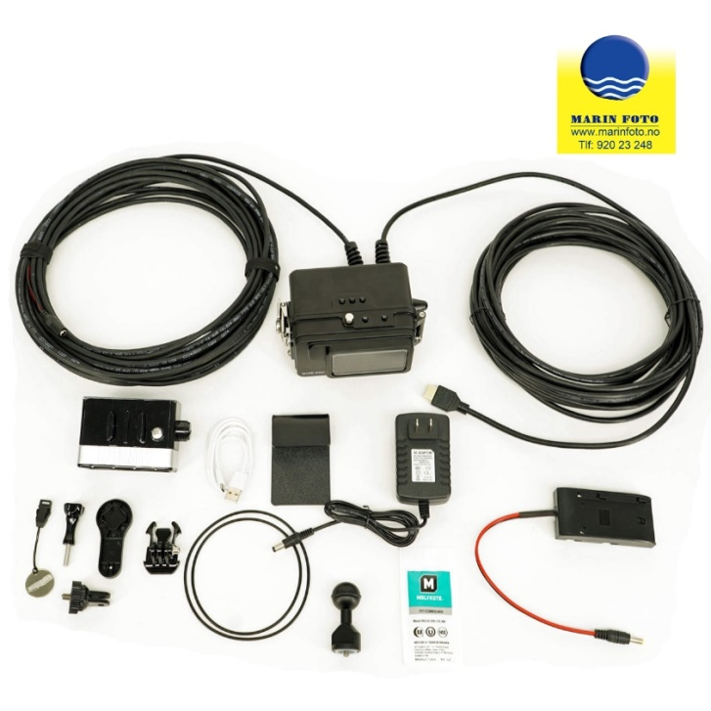
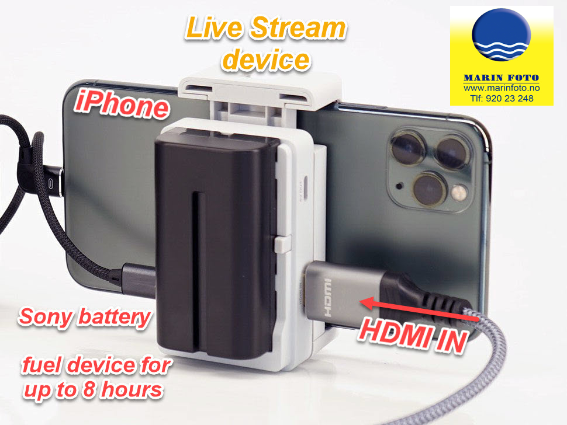The GoPro's internal battery will operate only 20-30 minutes underwater.
This is why our system uses an external power cable, allowing the GoPro to be powered from the surface - from a battery, car battery, solar panels, or a wall power supply - to ensure long and stable operation.

Our system will work with any HDMI monitor on the market, with no restrictions. The customer is free to use any brand or size they prefer - from very affordable small field monitors to larger professional displays. For budget-friendly options, many customers typically use simple 5"-7" HDMI monitors (brands like Feelworld, Portkeys, Lilliput, Atomos, etc.). As long as the monitor has a standard HDMI input, it will work perfectly with our 10m HDMI cable.

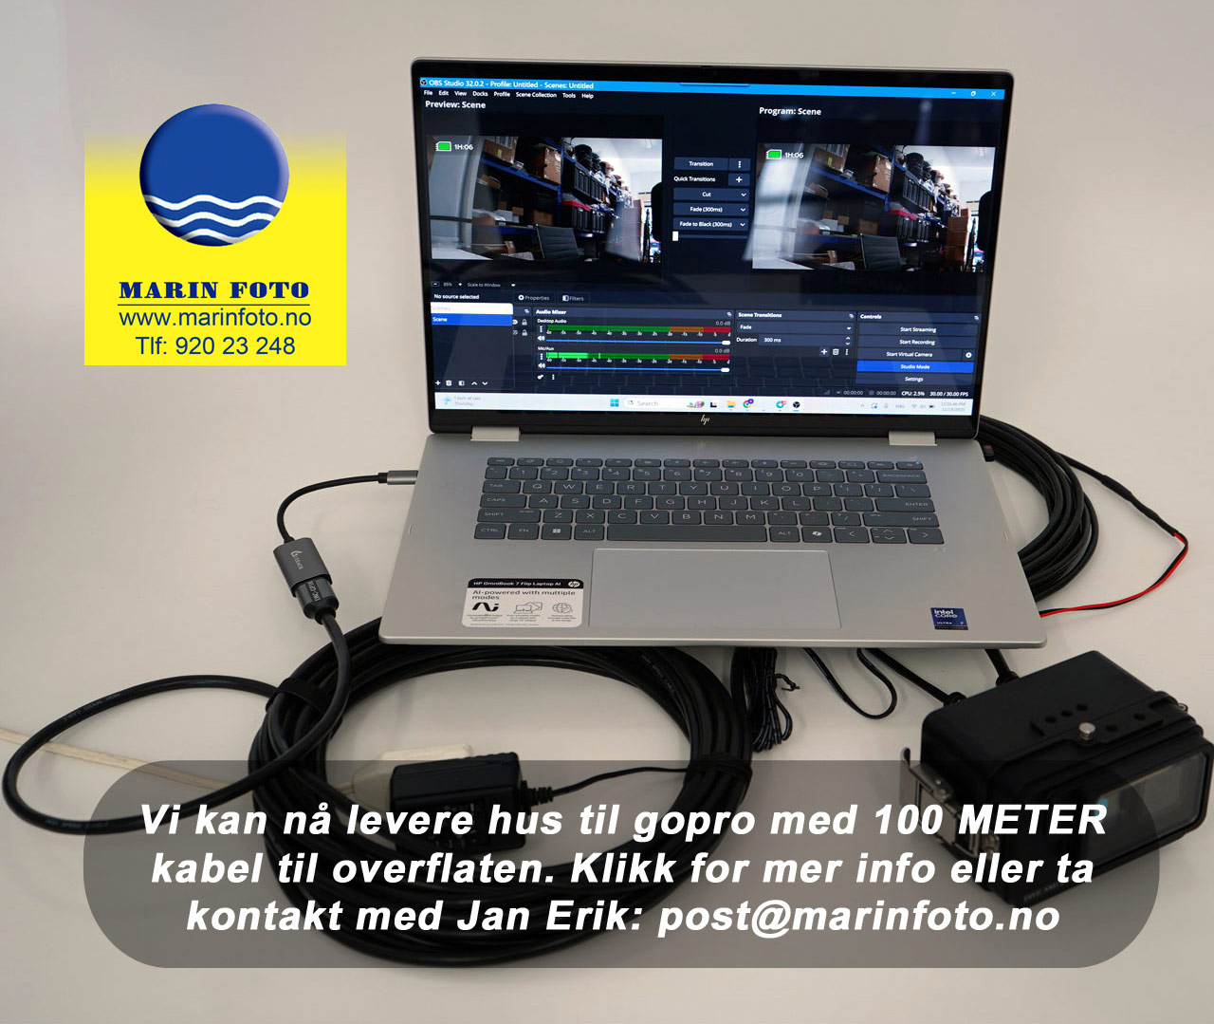
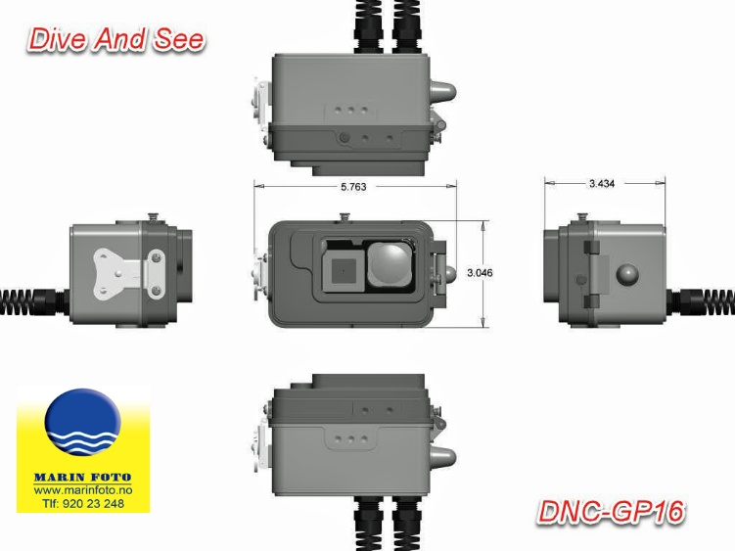

The Media Mod must be mounted on the GoPro camera before placing it inside the housing. This Media is required Mod adds for the GoPro HDMI Hero 9, 10, 11, 12, and 13 because these cameras do not have an HDMl port built in. The output and USB power input we need for underwater live streaming and external power.
Media Mod compatibility & price: Compatible with GoPro Hero 9, 10, 11, 12, and 13 Current price from GoPro: = $89.99 USD (the customer can buy it dírectly from GoPro or we can supply it) Yes Their small HDMI monitor will work The included 10m HDMI cable from the housing allows the customer to plug directly into: A small camera-top HDMI monitor A TV A computer capture card Any device with a standard HDMI input We can prepare a full quotation for the complete set, including: Dive And See housing 1 Power cable HDMI cable LED light Power supply/battery plate Media Mod (optional: supplied by us or purchased separately) 