- FISHEYE, WIDE ANGLE & MACRO LENSES -
We are very happy to be offering you the entire line of Inon product and apart from their superb strobes, they have the following equally impressive optical GLASS wide angle and super macro lenses for attachment to the Olympus and Canon range of digital housings. They are all very, very well priced and superbly designed and finished.

- UFL-165AD FISHEYE LENS -
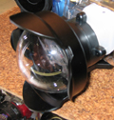
Pre-release picture taken at Inon, better pic will follow on release, but at least it gives you some sort of idea on it's very compact size. Lens is mounted to the Canon WPDC300 housing
*** AVAILABLE SOON ***
- One of the most amazing things that I have personally seen in 12 years of being involved in the underwater imaging market. A very, very compact, up to 165 degree fisheye lens, (varies with the camera), that has absolute enourmous depth of field, can be used on ANY housing that is listed below with the Inon AD lens mount and allows for the literally zero minimum focus. An extraordinary product.
- Yet more proof that Inon would have to be easily the most innovative company in the world of underwater imaging.
- 'AD' bayonet mount.
- Bayonet mount is able to be replaced in future years, if required, to extend the life of your lens at very low cost.
- Fisheye lens for use with the following housing models:
- - Canon WPDC900 - requires optional lens/fibre optic cable mount base 'ADDC900' - currently being designed
- - Canon WPDC800 - requires optional lens/fibre optic cable mount base 'ADDC800'.
- - Canon WPDC700 - requires optional lens/fibre optic cable mount base 'ADDC700'.
- - Canon WPDC500 - requires optional lens/fibre optic cable mount base ADDC500'.
- - Canon WPDC300 - requires optional lens/fibre optic cable mount base 'ADDC300'.
- - Canon WPDC200s - requires optional lens/fibre optic cable mount base 'ADDC200'.
- - Olympus PT-016 - requires optional lens/fibre optic cable mount base 'ADPT016'.
- - Olympus PT-014 - requires optional lens/fibre optic cable mount base 'ADPT014'.
- - Olympus PT-012 - requires optional lens/fibre optic cable mount base 'ADPT012'.
- - Olympus PT-009 - requires optional lens/fibre optic cable mount base 'ADPT009'.

- UWL-100 ACROMAT WIDE LENS -
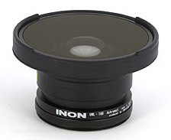
*** AVAILABLE FOR IMMEDIATE DELIVERY ***
- Optical GLASS construction.
- Fully machined aluminium body.
- Available in a package deal with the UCL-165M67 or UCL-330 macro glass lens. Makes for excellent buying.
- Includes the neoprene carry pouch, normally a factory option..
- 'M67' threaded mount.
- Wide lens for use with the following housing models:
- - Canon WPDC500 - requires optional lens/fibre optic cable mount base 'M67DC500'.
- - Canon WPDC300 - requires optional lens/fibre optic cable mount base 'M67DC300'.
- - Canon WPDC200s - requires optional lens/fibre optic cable mount base 'M67DC200'.
- - Olympus PT-018 - direct attachment.
- - Olympus PT-015 - direct attachment.
- - Olympus PT-014 - requires optional lens/fibre optic cable mount base 'M67PT014'.
- - Olympus PT-012 - requires optional lens/fibre optic cable mount base 'M67PT012'.
- - Olympus PT-010 - requires optional 'PT-005 adaptor ring'.
- Works a treat with nearly all Gates video housings with the use of specific Gates manufactured adaptors - call/email for details.
- Able to be mounted to selected Ikelite housings, see Ikelite's webpage for full details.

- DOME PORT for UWL-100 LENS -
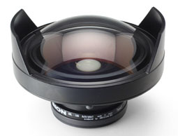
*** AVAILABLE FOR IMMEDIATE DELIVERY ***
- Optical GLASS construction.
- Fully machined aluminium body and protective shade. The dome can be placed down on the shade.
- Compact design.
- Includes the neoprene dome lens cover, normally a factory option.
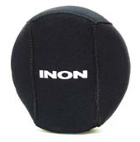
- UWL-100 lens is not included. This dome port is an add on accessory for the UWL-100 to give you a much wider angle of coverage.
- Currently the following housing models that accept the UWL-100 lens can use this fantastic add on accessory.
- - Canon WPDC500.
- - Canon WPDC300.
- - Canon WPDC200s.
- - Olympus PT-018.
- - Olympus PT-015.
- - Olympus PT-014.
- - Olympus PT-012.
- - Olympus PT-010.
- On the Olympus PT015 & Canon WPDC300 housings you are looking at around 128 degrees of coverage underwater - damn exciting and of course this product will be available to ANY system that accepts the Inon UWL-100 lens. This sort of angle of coverage can be pretty much expected from all of the above models.
- This is a superb GLASS dome lens that works out to be very well priced and finished - a product of the highest quality.
- Works a treat with the Gates 'Multi Port' system that of course uses the Inon UWL100 wide angle lens. Using the dome port will increase angle of coverage by a signficant amount on your Gates system - call/email for details

- UWL-105AD WIDE LENS -
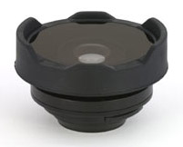
*** AVAILABLE FOR IMMEDIATE DELIVERY ***
- Optical GLASS multi coated construction.
- 'AD' bayonet mount.
- Bayonet mount is able to be replaced in future years, if required, to extend the life of your lens at very low cost.
- Available in a package deal with the UCL-165AD wide angle glass lens. Makes for excellent buying.
- Includes the neoprene carry pouch, normally a factory option.
- Wide lens for use with the following housing models:
- - Canon WPDC900 - requires optional lens/fibre optic cable mount base 'ADDC900' - currently being designed
- - Canon WPDC800 - requires optional lens/fibre optic cable mount base 'ADDC800'.
- - Canon WPDC700 - requires optional lens/fibre optic cable mount base 'ADDC700'.
- - Canon WPDC500 - requires optional lens/fibre optic cable mount base ADDC500'.
- - Canon WPDC300 - requires optional lens/fibre optic cable mount base 'ADDC300'.
- - Canon WPDC200s - requires optional lens/fibre optic cable mount base 'ADDC200'.
- - Olympus PT-016 - requires optional lens/fibre optic cable mount base 'ADPT016'.
- - Olympus PT-014 - requires optional lens/fibre optic cable mount base 'ADPT014'.
- - Olympus PT-012 - requires optional lens/fibre optic cable mount base 'ADPT012'.
- - Olympus PT-009 - requires optional lens/fibre optic cable mount base 'ADPT009'.

- UCL-165M67 MACRO LENS -
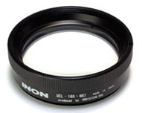
*** AVAILABLE FOR IMMEDIATE DELIVERY ***

- Optical GLASS, dual element, multi coated construction.
- 'M67' threaded mount.
- Stackable for super macro performance.
- Fully machined aluminium body.
- Significantly more magnification than the UCL-330 lens.
- Available in a package deal with the UWL-100 wide angle glass lens. Makes for excellent buying.
- Includes the neoprene carry pouch, normally a factory option.
- Macro close up lens for use with the following housing models:
- - Canon WPDC500 - requires optional lens/fibre optic cable mount base 'M67DC500'.
- - Canon WPDC300 - requires optional lens/fibre optic cable mount base 'M67DC300'.
- - Canon WPDC200s - requires optional lens/fibre optic cable mount base 'M67DC200'.
- - Olympus PT-020 - direct attachment.
- - Olympus PT-018 - direct attachment.
- - Olympus PT-015 - direct attachment.
- - Olympus PT-014 - requires optional lens/fibre optic cable mount base 'M67PT014'.
- - Olympus PT-012 - requires optional lens/fibre optic cable mount base 'M67PT012'.
- - Olympus PT-010 - requires optional 'PT-005 adaptor ring'.
- Works a treat with nearly all Gates video housings with the use of specific Gates manufactured adaptors - call/email for details.
- Able to be mounted to selected Ikelite housings, see Ikelite's webpage for full details.

- UCL-330 MACRO LENS -
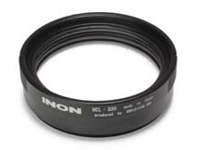
*** AVAILABLE FOR IMMEDIATE DELIVERY ***
- Optical GLASS, dual element, multi coated construction.
- 'M67' threaded mount.
- Stackable for super macro performance.
- Fully machined aluminium body.
- Available in a package deal with the UWL-100 wide angle glass lens. Makes for excellent buying.
- Includes the neoprene carry pouch, normally a factory option.
- Macro close up lens for use with the following housing models:
- - Canon WPDC500 - requires optional lens/fibre optic cable mount base 'M67DC500'.
- - Canon WPDC300 - requires optional lens/fibre optic cable mount base 'M67DC300'.
- - Canon WPDC200s - requires optional lens/fibre optic cable mount base 'M67DC200'.
- - Olympus PT-020 - direct attachment.
- - Olympus PT-018 - direct attachment.
- - Olympus PT-015 - direct attachment.
- - Olympus PT-014 - requires optional lens/fibre optic cable mount base 'M67PT014'.
- - Olympus PT-012 - requires optional lens/fibre optic cable mount base 'M67PT012'.
- - Olympus PT-010 - requires optional 'PT-005 adaptor ring'.
- Works a treat with nearly all Gates video housings with the use of specific Gates manufactured adaptors - call/email for details.
- Able to be mounted to selected Ikelite housings, see Ikelite's webpage for full details.

- UCL-165AD MACRO LENS -
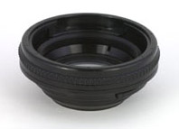
*** AVAILABLE FOR IMMEDIATE DELIVERY ***
- Optical GLASS, dual element, multi coated construction.
- 'AD' bayonet mount.
- Stackable for super macro performance.
- Bayonet mount is able to be replaced in future years, if required, to extend the life of your lens at very low cost.
- Available in a package deal with the UCL-105AD wide angle glass lens. Makes for excellent buying.
- Includes the neoprene carry pouch, normally a factory option..
- Macro close up lens for use with the following housing models:
- - Canon WPDC900 - requires optional lens/fibre optic cable mount base 'ADDC900' - currently being designed
- - Canon WPDC800 - requires optional lens/fibre optic cable mount base 'ADDC800'.
- - Canon WPDC700 - requires optional lens/fibre optic cable mount base 'ADDC700'.
- - Canon WPDC500 - requires optional lens/fibre optic cable mount base ADDC500'.
- - Canon WPDC300 - requires optional lens/fibre optic cable mount base 'ADDC300'.
- - Canon WPDC200s - requires optional lens/fibre optic cable mount base 'ADDC200'.
- - Olympus PT-016 - requires optional lens/fibre optic cable mount base 'ADPT016'.
- - Olympus PT-014 - requires optional lens/fibre optic cable mount base 'ADPT014'.
- - Olympus PT-012 - requires optional lens/fibre optic cable mount base 'ADPT012'.
- - Olympus PT-009 - requires optional lens/fibre optic cable mount base 'ADPT009'.

- OTHER ACCESSORIES -
- GRIP BASE II ARM/TRAY COMBO-
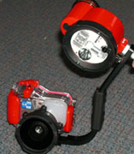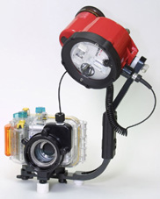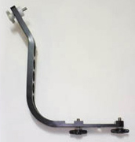
Inon Grip Base II all-in-1 arm/tray aluminium assembly as pictured above. Left pic is fitted to the Olympus PT014 housing and D180 strobe :: middle pic is with Canon WPDC700, ADDC700 lens mount and D180 with cable fitted :: right pic is the Grip Base II by itself
*** AVAILABLE FOR IMMEDIATE DELIVERY ***
- 'M67' & 'AD' LENS MOUNT BASES -
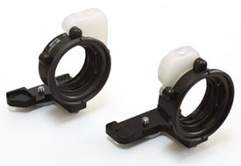
*** AVAILABLE FOR IMMEDIATE DELIVERY ***
- The above mount bases are required with most Canon and Olympus housings - see list above with each lens.

- 'M67' & 'AD' MOUNT LENS POUCHES -
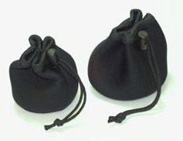
- We are supplying these neoprene lens pouches as a 'standard' item when any of these lenses are purchased from us. They are normally an option from the factory.
- 'M67' & 'AD' MOUNT LENS HOLDERS -
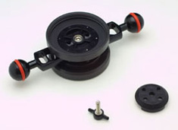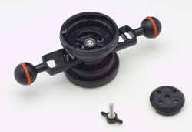
*** AVAILABLE FOR IMMEDIATE DELIVERY **
- Optional, but very worthwhile accessory.
- Able to be mounted to the Ultra Light 5", 8", 12" and 16" double ball arms.
- Able to be mounted to the Inon Grip Base II arm/tray combo.
- Dual 'M67' or 'AD' type lens mounts for mounting 2 lenses at once on our chosen arm. Please also note that mounting hardware is also included to mount a single lens as well.

